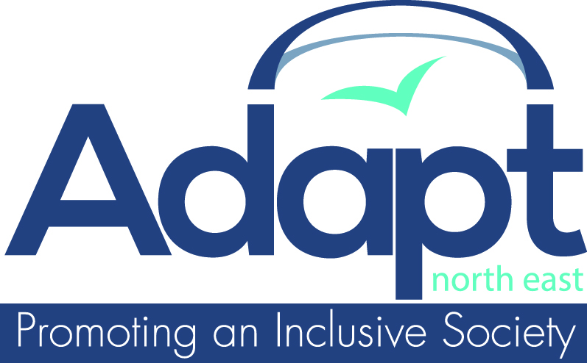

APPLICATION FORM

Post applied for | Café Assistant

Name
Address

Postcode
Telephone number (day)
Telephone number (eve)
E-mail address
Do you have a disability?

This page is for monitoring purposes only and will be removed before shortlisting.
To enable to us to monitor equality of opportunity, we would appreciate it if you would give us the following information (please mark boxes as appropriate):

Date of birth

Gender | Male
 | Female

Marital status | Single
 | Living with partner
 | Married

Ethnic group | White British |  | Asian British
 | White Other |  | Asian Other
 | Black British |  | Chinese
 | Black Other |  | Other
 | Mixed |  | Prefer not to say

This page to be left blank

EDUCATION

Date (from) | Date (to) | Establishment  (name and address) | Qualifications  (subject and grade)

Do you have any other qualifications that are not mentioned above?

EMPLOYMENT HISTORY

Date (from) | Date (to) | Employer  (name and address) | Position held | Reason for leaving

Do you have any other experience relevant to this post?
(Please include any voluntary work)

What attracts you to this post and what do you think makes you suitable for it?

Do you have a current full driving licence?

Interests:

Please provide the name and address of two Referees, one of whom should be a present or recent employer:

Name

Organisation

Address

Telephone number

In what capacity known

Do you have any objections to our approaching your referees prior to interview?

I confirm that, to the best of my knowledge, the information given on this form is correct and can be treated as part of any subsequent contract of employment.

Please return this form to: Adapt North East
Burn Lane
Hexham
Northumberland NE46 3HN

Or e-mail it to: general-office@adapt-tynedale.org.uk

General Data Protection Regulation – Consent
General Data Protection Regulation (GDPR) came into force on the 25th May 2018. GDPR requires us to provide information about how we use and store your personal data.
To ensure our continued compliance with data protection and privacy laws, we require your consent to store your data (information that relates to and identifies living people). We will always make sure that your information is protected and treated securely. Any information that you give will be held in accordance with:
- The Data Protection Act 1998
- As of 25th May 2018, the new data protection legislation introduced under the General Data Protection Regulation (GDPR) and Data Protection Bill.
Please read carefully the statement below then sign and date the declaration and return the consent with your application form. If you have any questions, please feel free to contact me.
Kind regards
Liz Prudhoe, Director
……………………………………………………………………………………………………………………………………………………………
- I consent to Adapt (NE) storing my personal data; this data will be retained and destroyed after three months of receipt.

Full name: ……………………………………………………………………………..

Signature: …………………………………………………………………………….. Date: ……………………………………

