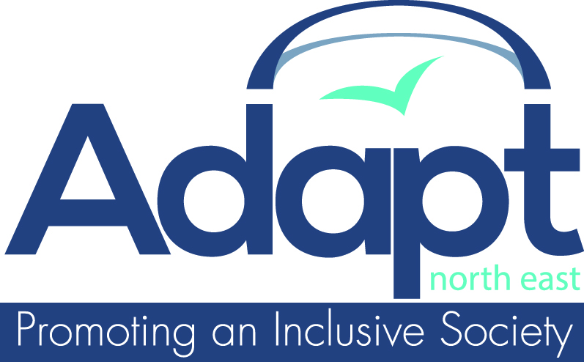

Adapt (North East) Membership

I would like to: (please indicate)
Become a member of Adapt

Renew my subscription to Adapt

£4 Individual
£15 Community Group
£25 Community Group plus four free volunteer DBS checks
£35 Funded Voluntary Group
£35 Funded Voluntary Group plus four free volunteer DBS checks
£45 Statutory Body or Private Company

Title: First name: Surname:
Organisation (if applicable):
Address:

Post code: Tel. no.

Date of birth (used only for our statistics):

If you would prefer to receive your newsletters by e-mail, please let us know your
e-mail address:

If you would prefer to receive your newsletters in any other format please let us know:

If you would prefer to receive your newsletters or emails in a language other than English please enter language format:

Please tick here if you are interested in receiving
information about any organised trips from your area.

Name Signature Date
Data Protection: By signing this form you confirm that you give us permission to add your details to our database for 12 months which will remain confidential and will not be shared with anyone else. Your data will be used by Adapt (North East) for the purpose of communication only.
Please tick the box to show your consent:
We are very interested in your views and thoughts on what type of services Adapt (NE) should be looking to develop for the future.

Please take this opportunity to let us know how our services are working now and what new services you would wish to see developed.

What new services or sessions would you wish to see developed in the Community Café?

Are there any comments you wish to make about Adapt’s existing services?

Please return this form to us with your subscription.
Adapt (North East), Burn Lane, Hexham, Northumberland NE46 3HN
Tel: 01434 600599 Fax: 01434 605251 www.adapt-ne.org.uk

